**ZEROTH LEVEL DFD FOR STUDIO MANAGEMENT SYSTEM**

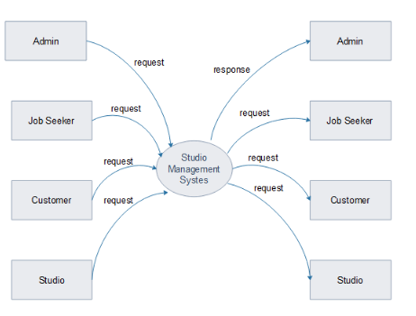

**FIRST LEVEL DFD FOR ADMIN**

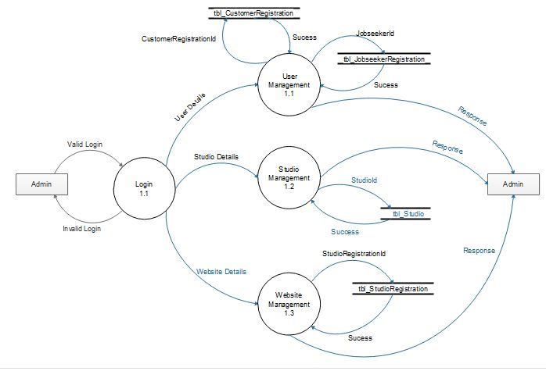

**FIRST LEVEL DFD FOR STUDIO**

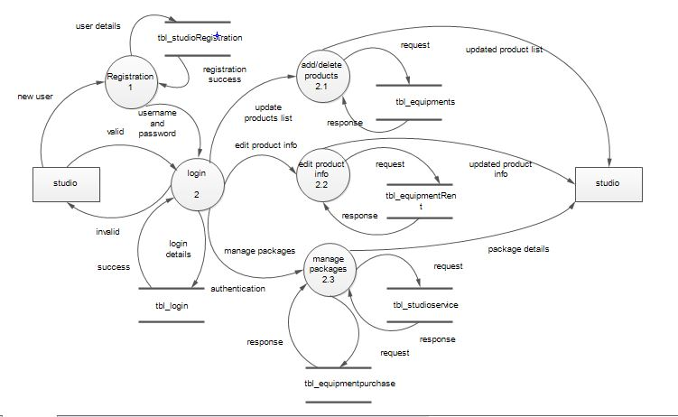

**FIRST LEVEL DFD FOR CUSTOMERS**

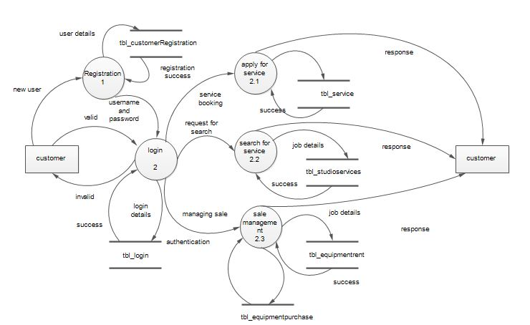

**FIRST LEVEL DFD FOR JOB SEEKER**

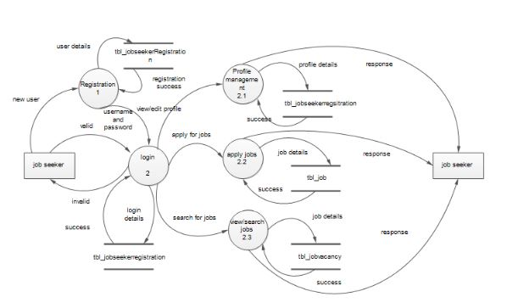

**SECOND LEVEL DFD FOR STUDIO MANAGEMENT OF ADMIN**

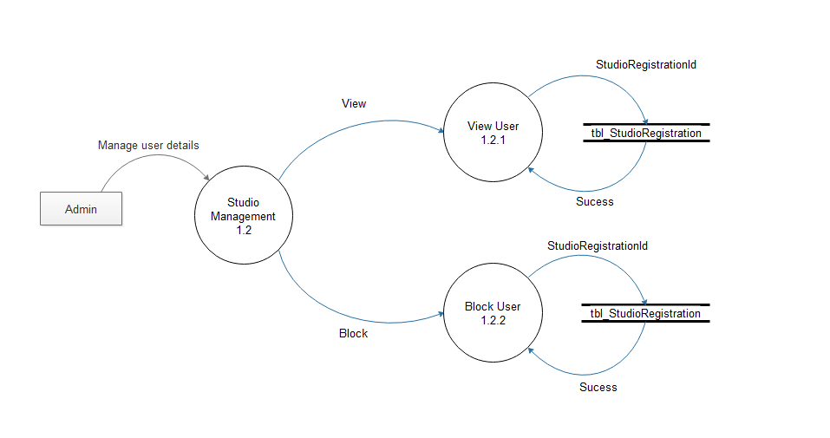

**SECOND LEVEL DFD FOR USER MANAGEMENT OF ADMIN**

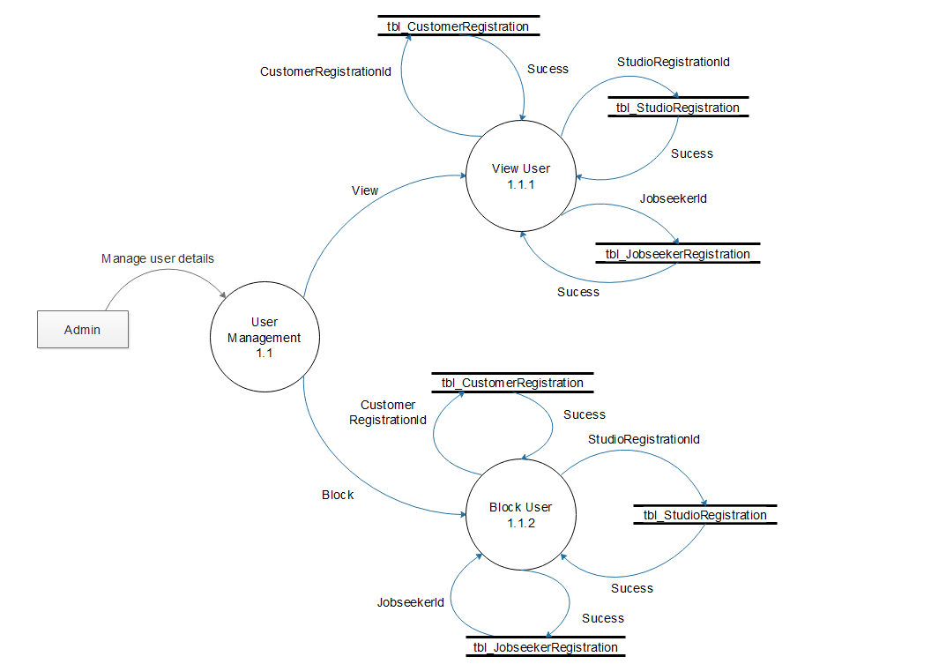

**SECOND LEVEL DFD FOR WEBSITE MANAGEMENT OF ADMIN**

